**Practical on VM Migration**

Name: Tanisha Agrawal

Roll No: A13

**Aim:**To show the Virtual Machine Migration based on the certain condition from one

node to the other.

Note: please refer the video for full explanation the screenshots are taken from video

PROCEDURE:

I have cloned the VM for performing this practical

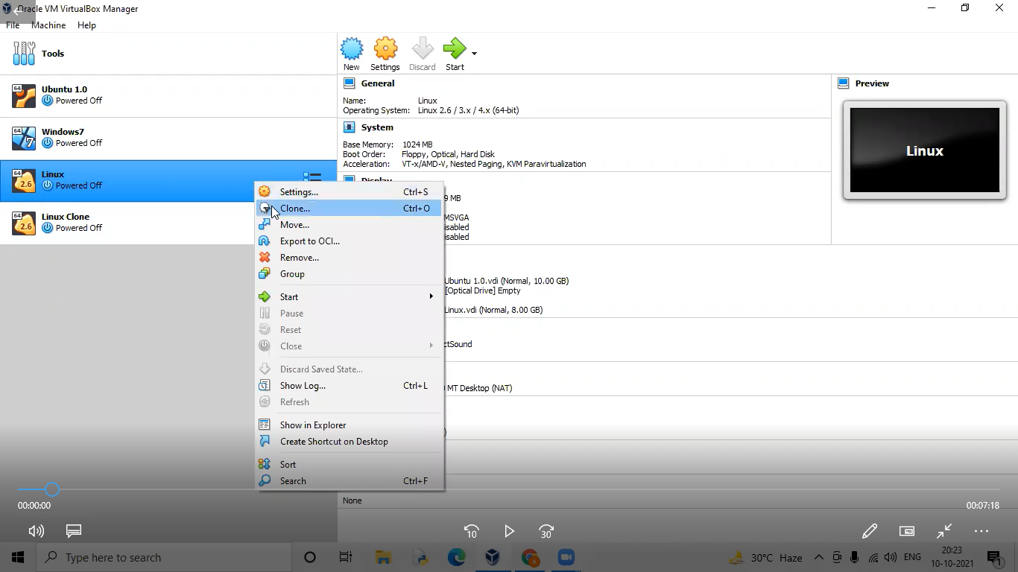

Step1: Select the VM and click File->Export Appliance

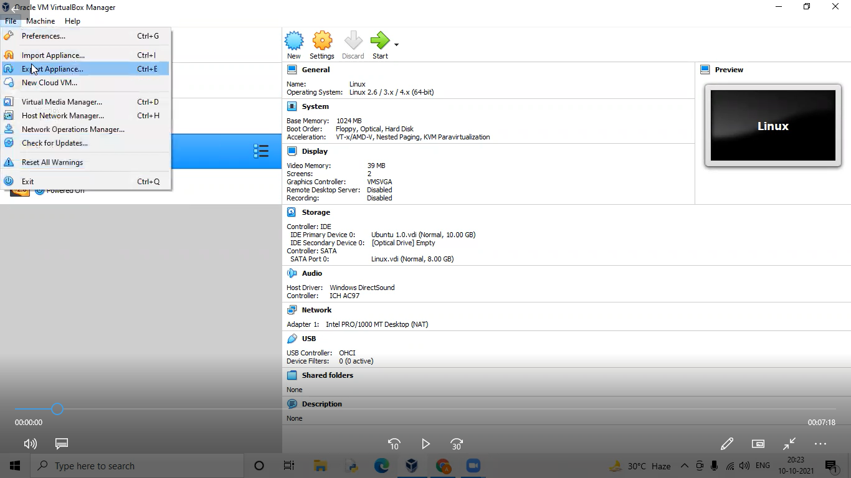

Step2: Select the VM to be exported and click NEXT.

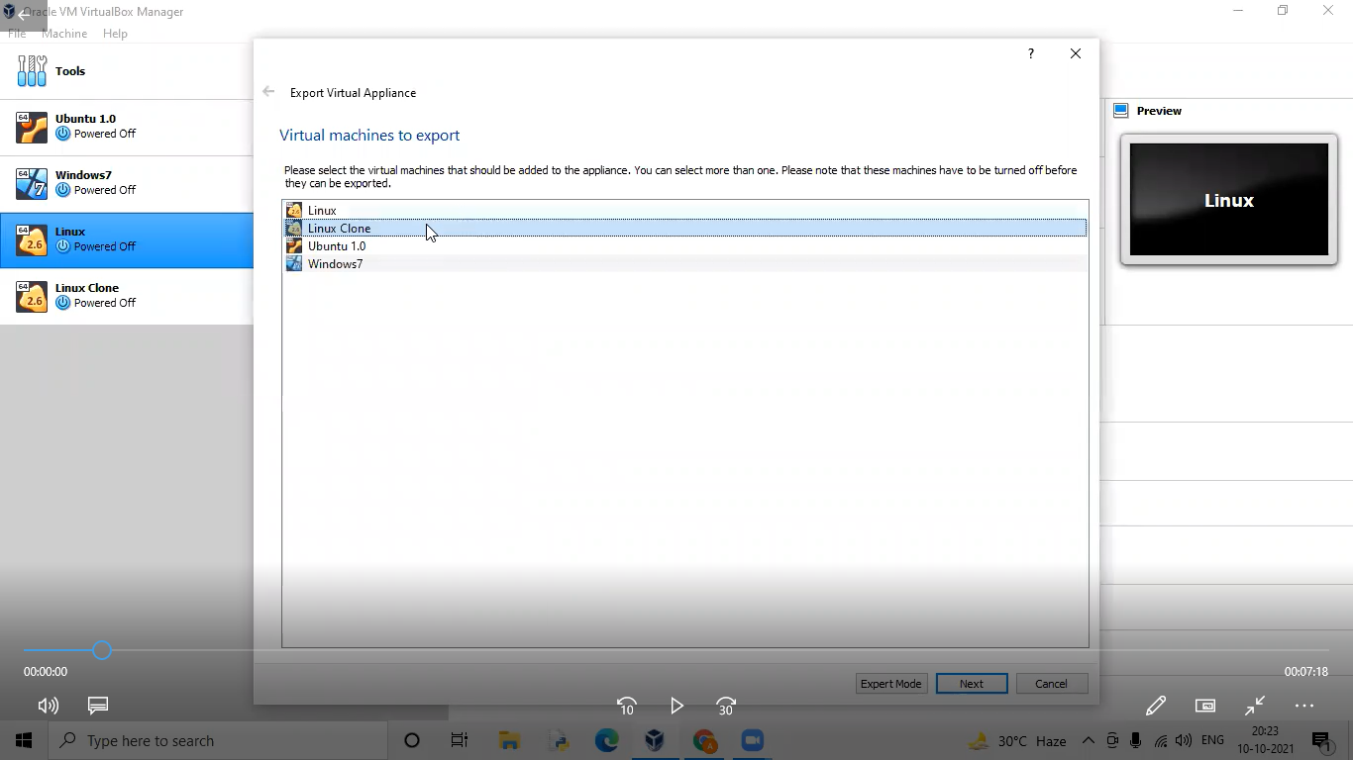

Step3: Note the file path and click “Next”

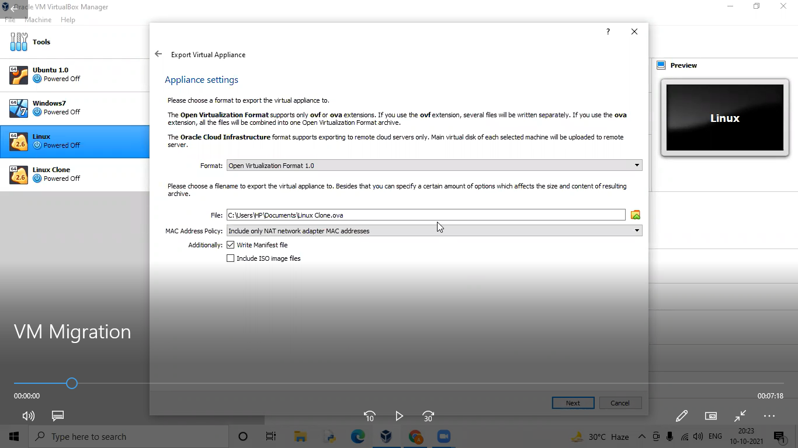

Step4: Click “Export”

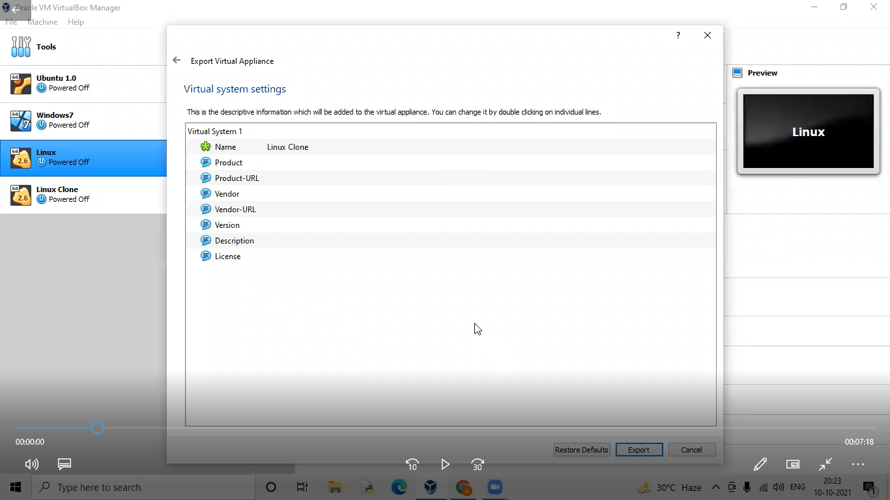

Step5: The Virtual machine is being exported.

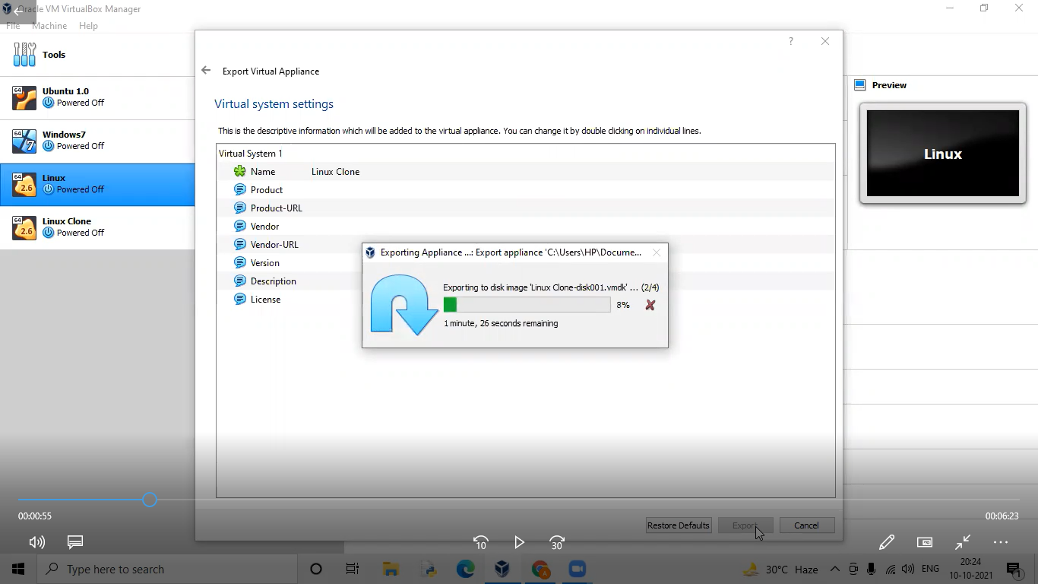

Step6: Install “ssh” to access the neighbour's VM.

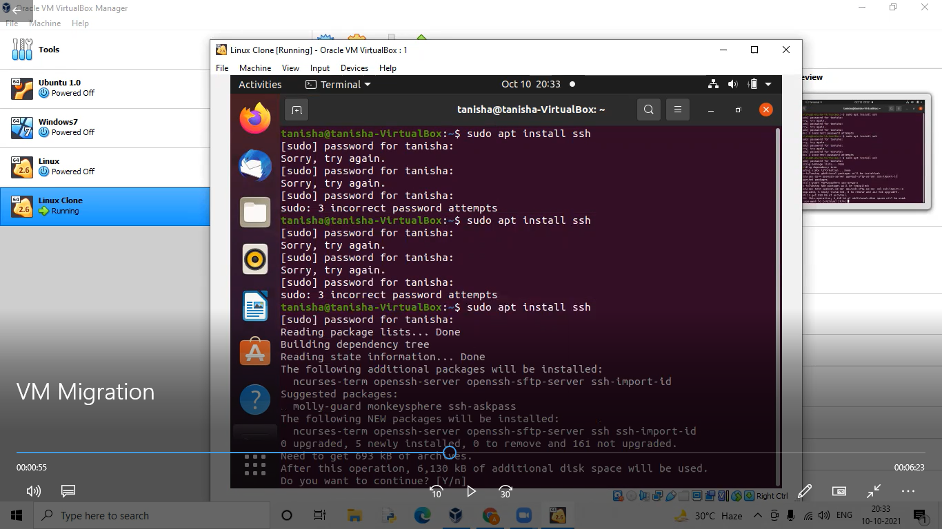

Step7: Go to File->Computer:/home/tanisha/Documents/

Step8: Type the neighbour's URL: sftp://tanisha@192.168.56.101/[the url can be acquired from iconfig]

Step9: Give the password and get connected.

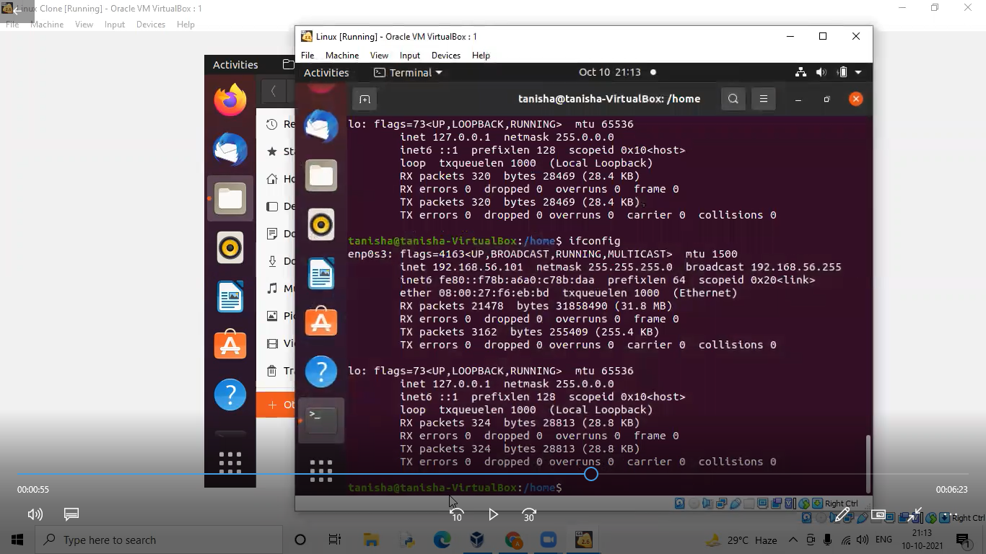

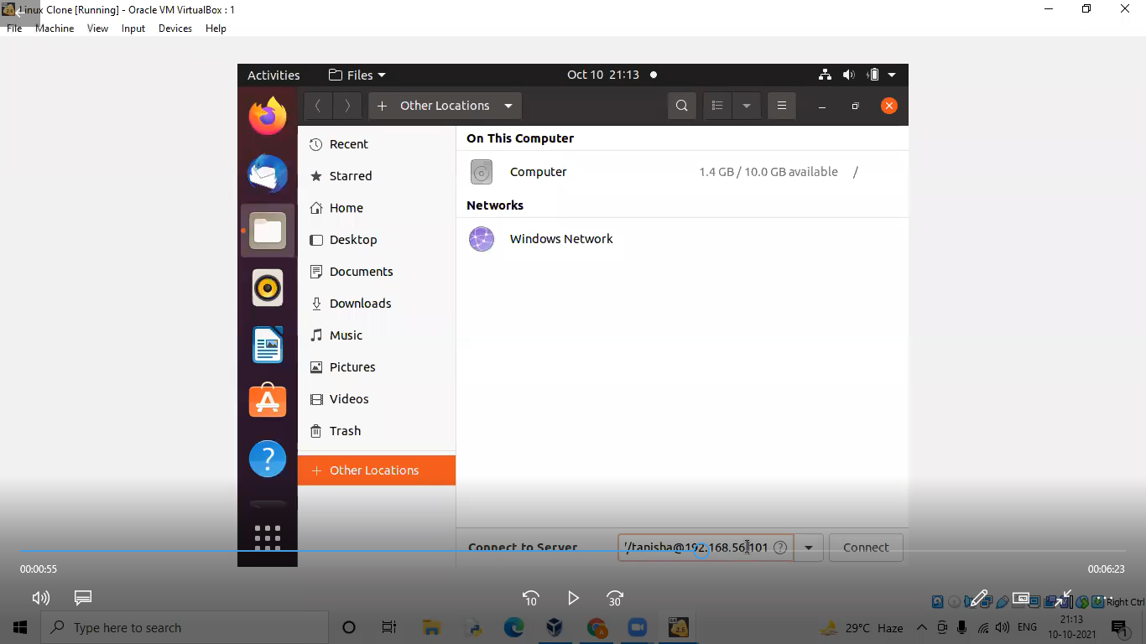

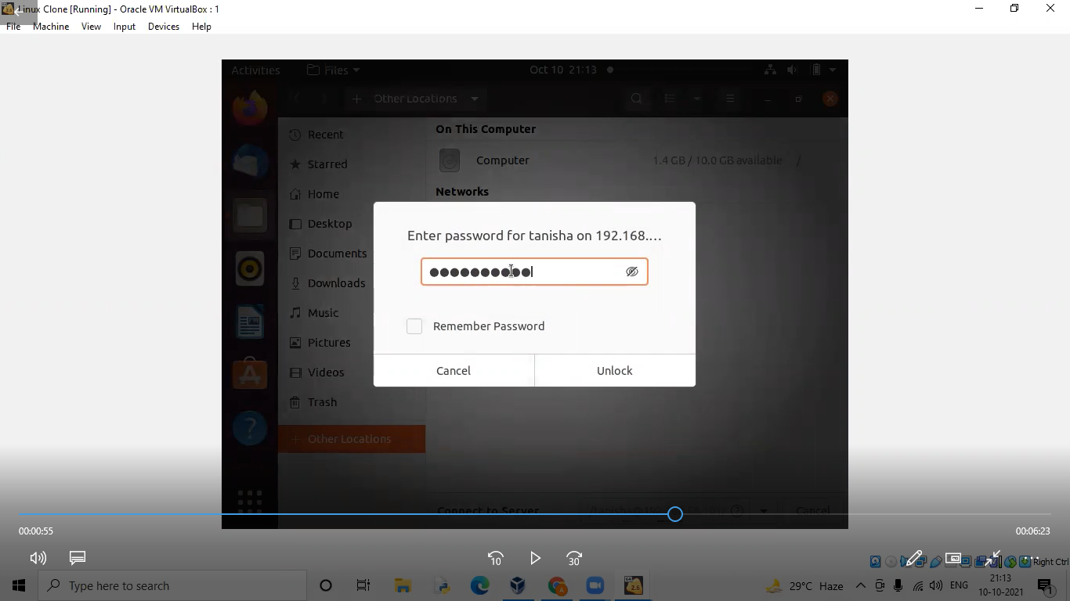

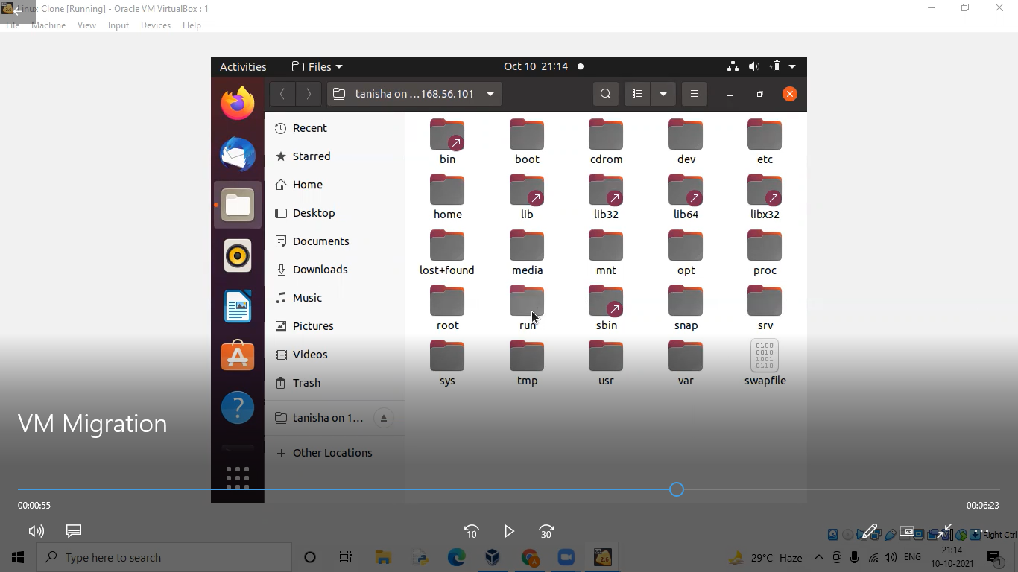

Step10: Select the VM and copy it in desktop.

Step11: Open VirtualBox and select File->Import Appliance->Browse

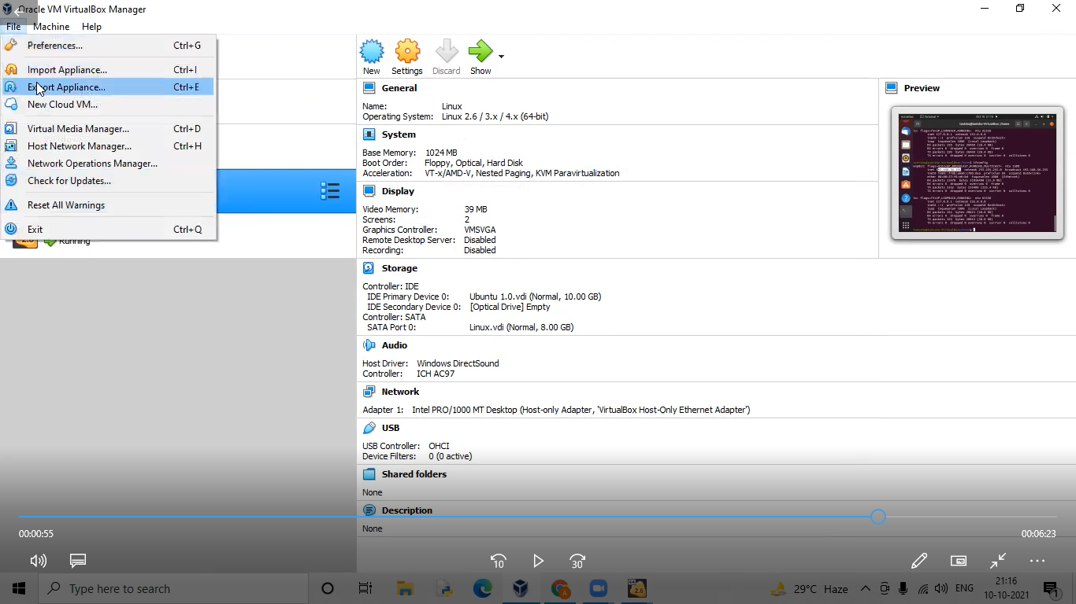

Step12: Select the VM to be imported and click “Open”.

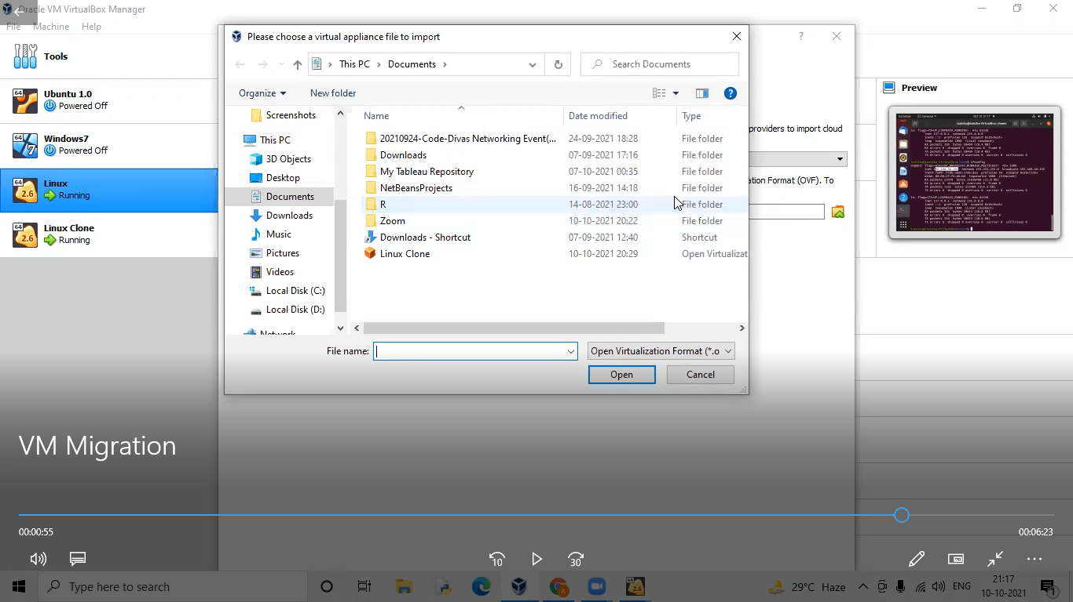

Step13: Click “Next” button.

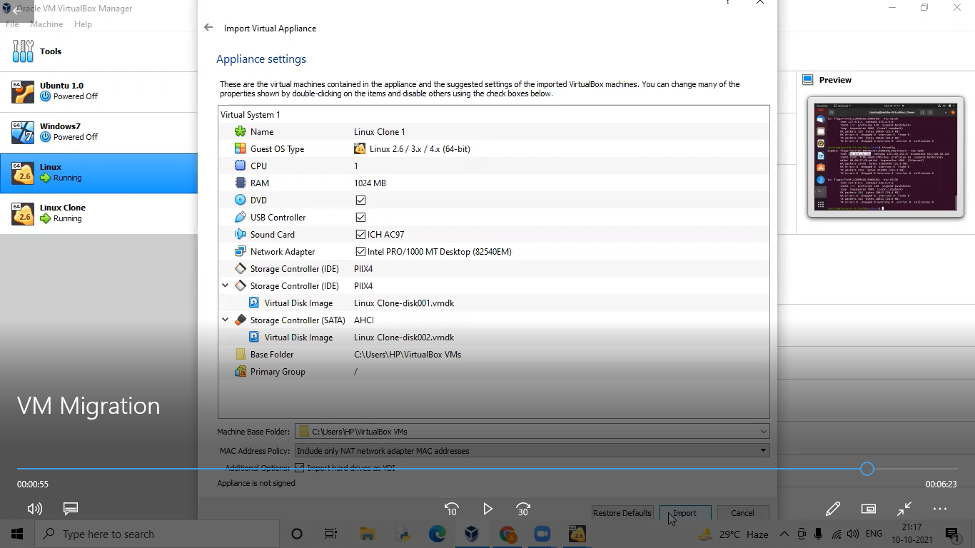

Step14: Click “Import”.

Step15:TheVirtual Machine starts to get imported.

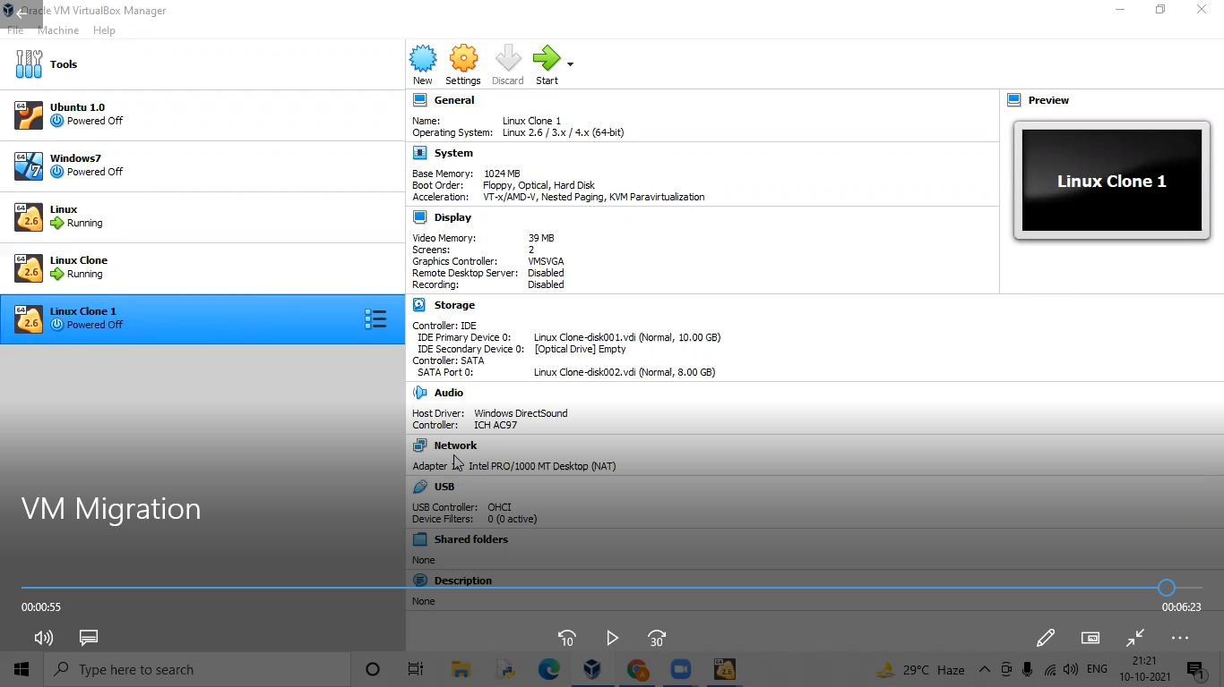

Step16: Thus the VM is imported.

RESULT:

Thus,Virtual machine migration has been implemented successfully.